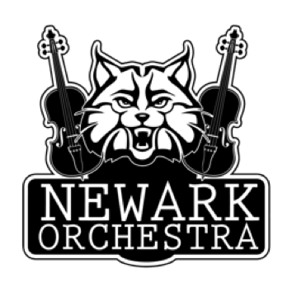
Orchestra Polo Shirt Order Form
Each student in the Newark City Schools Middle School Orchestra program needs to have a black Newark Orchestras Uniform Polo shirt.
We wear these special polos for all concerts throughout their entire middle school orchestra career. It is recommended that you buy your student a shirt that will fit for their entire time in middle school.
The cost of the polo shirt is $18.50.
Please return the order form with either
Cash or Check made out to NOPA (Newark Orchestra Parent Association) in a sealed envelope by Sept. 20

Student Name: __________________________________________
Shirt Size:
Child Small Child Medium Child Large Child XL
Adult Small Adult Medium Adult Large Adult XL

If purchasing this shirt is a problem, please email arudd@newarkcityschools.org and we will come up with a solution!

