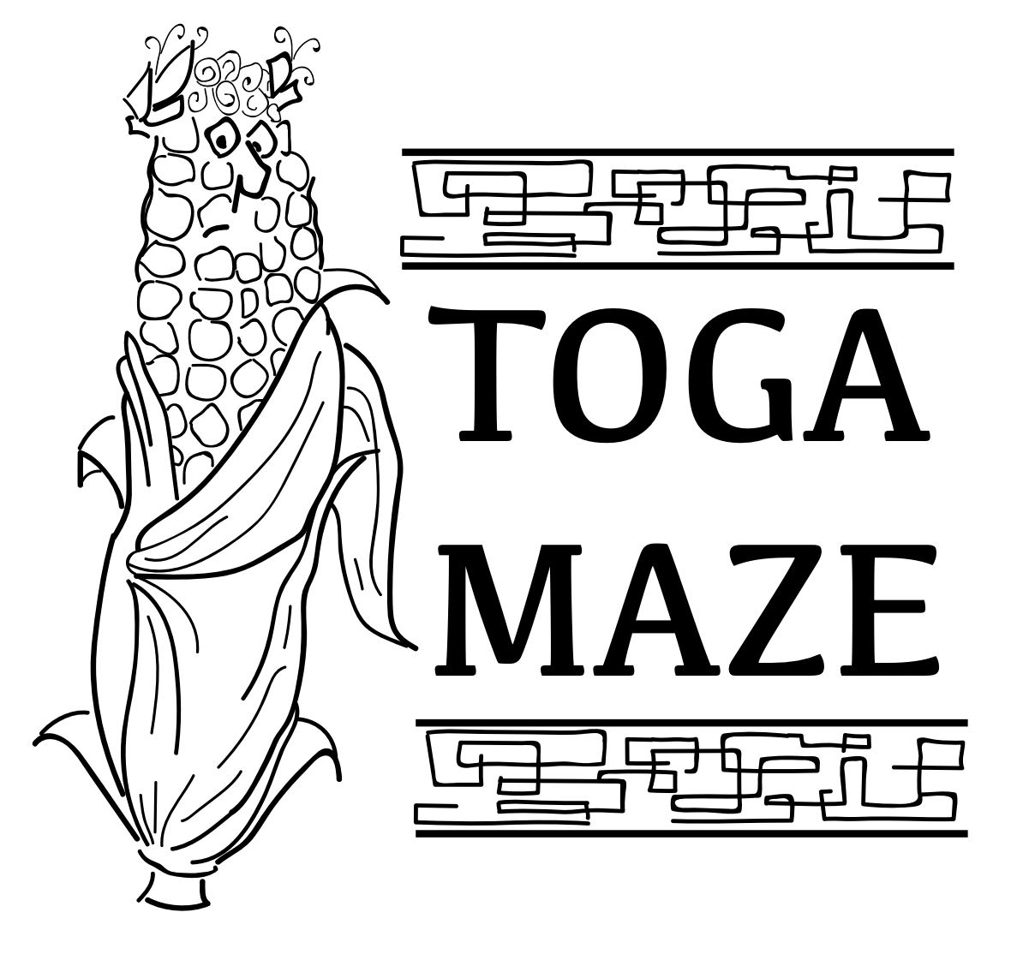
Where | Lynd’s Fruit Farm in Pataskala, OH
Who | All Middle School Orchestra Students
When | Thursday October 20th
Depart | 6 pm from NHS Fine Arts Building
Return | 9:00 pm to NHS Fine Arts Building
Cost | $15 per student  $10 per adult chaperone
Bring | Warm clothing, flashlight, and adventurous spirit

All school rules will be in effect. Students will be under the supervision of their teachers and adult chaperones. Chaperones are welcome and NEEDED!
More information at http://www.lyndfruitfarm.com/corn-maze/
Lynd’s has the following additional rules:
- Each Student group must be accompanied by an adult
- No Running
- No foul language
- Do not pick or throw the corn
- Stay on the roped path
- Do not go under the rope
- Do no cut through the corn
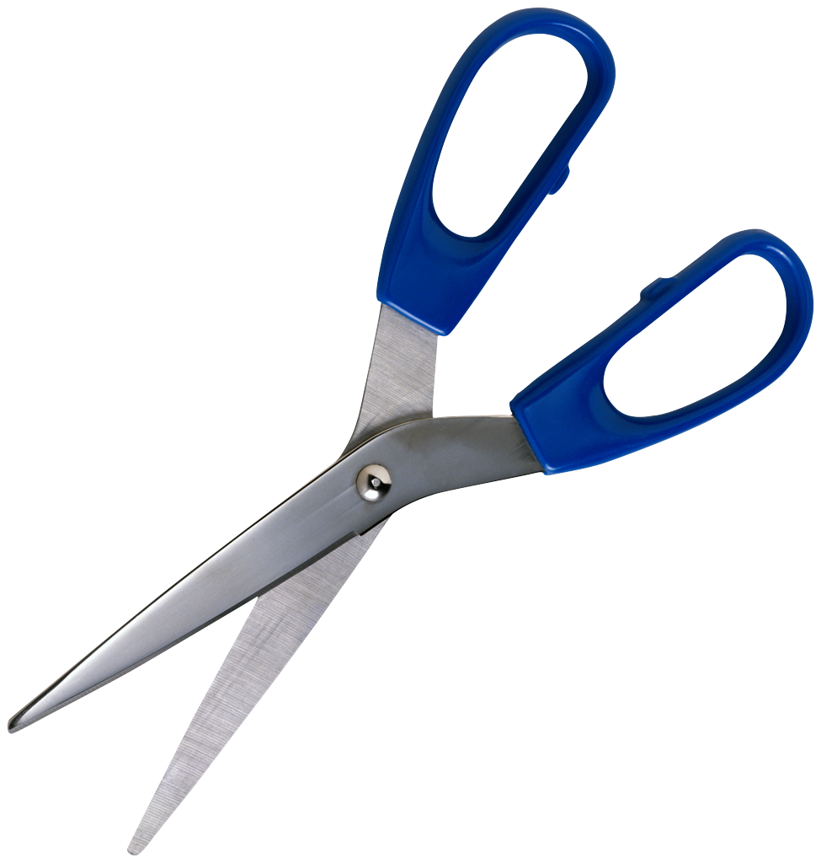---------------------------------------------------------------------------------------------------------------
Permission Form
Return form along with payment to your orchestra director by Oct. 7th

My child ___________________________________ has permission to attend the trip to Lynd's Fruit Farm. I understand that my child will be transported to and from this event by a Newark City Schools bus. I also understand the expectations set forth by Lynd's Fruit Farm for this activity.

____________________________________________ ________________________
Parent Signature Parent Phone Number
☐ Check if interested in being a chaperone

